2.14 Read the text and find information about: (Сделать письменный корректный контекстный перевод)
a. difference between colleges and universities
- graduate and post-graduate degrees
- students’ majors
- forms of instruction

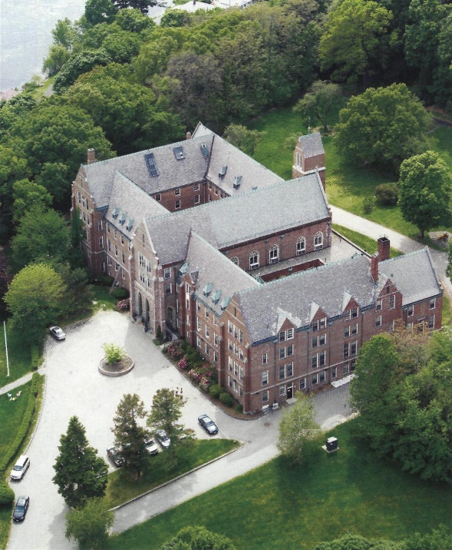
In the U.S.A. the students can get higher education both in colleges and universities. The major difference between colleges and universities is that colleges are four-year institutions, and universities offer longer courses of study. College is usually an institution the curriculum of which emphasizes arts and sciences or liberal arts, a combination of natural and social sciences and the humanities. Academic work at a college leads to a four-year Bachelor of Arts (B.A.) or Bachelor of Science (B.S) degree.
Universities are usually composed of several undergraduate colleges and offer graduate (Master of Arts or M.A, Master of Science or M.S.) and post-graduate degrees (Doctor of Philosophy or Ph.D., Doctor of Education or Ed.D.)
Every American student has a major, i.e. the primary area of concentration. They may choose, for instance, English literature, Biology, Political Science, etc. Students are often required to take the majority of their courses in their declared major. Some courses are required by institutions of higher education, such as English, social science, and humanities courses. A certain number of courses are elected by students according to their interests alone.
The most common form of instruction in colleges and universities is lecturing. Laboratories are also often used for computer and science projects as well as for language courses. Teachers in the USA also make use of discussion groups where the students discuss a work of literature or an essay and prepare a group presentation on a related topic.

Grammar

6.36 Put much or many before the nouns.

1.______students
2. ______exams
3. ______coffee
4. ______libraries
5. ______love
6. ______food
7. ______ rooms
8. ______ tea
9. ______ computers
10. ______juice

6.37 Put little or few before the nouns.

1. ______work
2. ______jobs
3. ______ computers
4. ______milk
5. ______ motorbikes
6. ______money
7. ______notebooks
8. ______chocolate
9. ______ideas
10. ______colleges

  - Write comparative and superlative forms of the adjectives.
Adjective | Comparative | Superlative
1. old
2. young
3. intelligent
4. happy
5. interesting
6. new
7. difficult
8. fast
9. popular
10. good

6.39 Complete the questions with the superlative form of the adjective. Answer them.
1. What is ______ (long) river in the world?
2. What is ______ (big) city in your country?
3. What is ______ (high) mountain in the world?
4. What is ______ (popular) sport in your country?
5. Where is ______ (old) university in Europe?
6. Who is ______ (young) person in your family?
7. Who is ______ (intelligent) student in your class?

6.40 Match the columns.
А В

1. 567
2. 9th
3. 1987
4. 11,000,000
5. 0.36
6. October 12
7. 1/7
8. 2.18
9. 88-63-01
10. 1805
a. Eleven million
b. One seventh
c. Point thirty- six
d. The ninth
e. Five hundred and sixty-seven
f. Double eight six three oh one
g. The twelfth of October
h. Eighteen oh five
i. Two point eighteen
j. Nineteen eighty-seven

