Writing

4.1 You have received a letter from your English pen friend Nick who writes
… At college we have a variety of cultural, musical, social clubs and organizations. Could you tell me about student organizations that are the most popular in your university?
By the way, I am going to join the Wildlife Club …

4.2 Write a letter to Nick. In your letter tell him about different student social activities (clubs and organizations) of your university. Ask 3 questions about the Wildlife Club. Remember the rules of letter writing.
Your address
Date
Dear Nick,
Thanks for …, or Many thanks for ….
Please write to me or
I’m looking forward to hearing from you soon or
Best wishes or Love,
Your name

Self – study

Find information about any British (European) or American university. Present this information to your groupmates. ( Найти информацию о любом Британском или Американском вузе и сделать презентацию. Можно использовать Power Point)

Grammar

5.1 Look at the picture. Say what children are doing at the math class.

The director is looking into the classroom. A young teacher is speaking. But the children are not interested in math. They are doing something else. Tom______ (not/write) in his notebook, he______ (read) a history book. Sally______ (not/listen) to the teacher, she______ (talk) with her friend. Sandy______ (not/look) at the blackboard, she______ (talk) on the mobile phone.

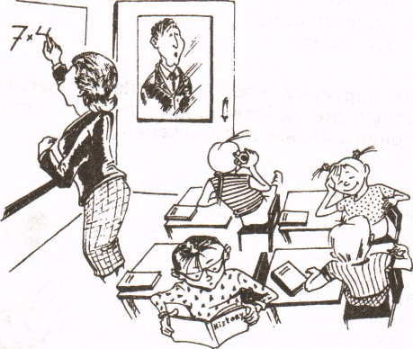

5.2 Put in am/is/are/do/don't/does/doesn't.
1. Excuse me, ______ you speak English?
2. Where ______ you come from? I ______from Canada.
3. A: Where’s George?
B: He ______ having lunch in the café.
4. What ______ she do? She's a programmer.
5. I ______want to go out. It ______ raining.
6. I can't talk to you at the moment. I ______ working.
7. George is good at tennis, but he ______ play very often.
8. ______ you enjoy your English course?

5.3 Put the verb in the Present Progressive (I am doing) or Present Simple (I do).
1. ______ (you/study) full-time at university?
2. Tom______ (have) a lecture at the moment.
3. They______ (not/skip) lectures.
4. Listen! Somebody______ (speak).
5. How often______ (you/have) seminars?
6. A: Excuse me, but you______ (sit) in my place.
B: Oh, I'm sorry.
7. I'm sorry, I______ (not/understand). Please, speak more slowly.
8. A: Where are you, Roy?
B: I’m in the sitting-room. I______ (read).
9. What time______ (she/finish) work every day?
10. He_____ (not/usually/drive) to the university. He usually_____ (walk).

5.4 Are the sentences correct or incorrect? Correct the mistakes.
1. I usually working from 7.30-13.30.
2. Does he has his own car?
3. I often having dinner with them.
4. He never skip classes.
5. She does not reads a lot.
6. Where are you work now?
7. She usually do her homework in the library.
8. We don't live on campus now.
9. She doesn't works in London.
I0. Is he study hard?

5.5 Choose the correct form of the verb.
1. I am thinking / think it's not easy to learn English.
2. She is having/has a shower. Can you call later?
3. She isn't having/doesn't have a new car.
4. He is having/has a lecture at the moment.
5. They are wanting/want to go to the library.
6. I don't think she is understanding/understands.
7. I am liking/like programming.
8. He is knowing/knows a lot about computers.

