2.10 Read the text and find information about:
а. British colleges and universities
b. graduate and post-graduate degrees
c. forms of instruction
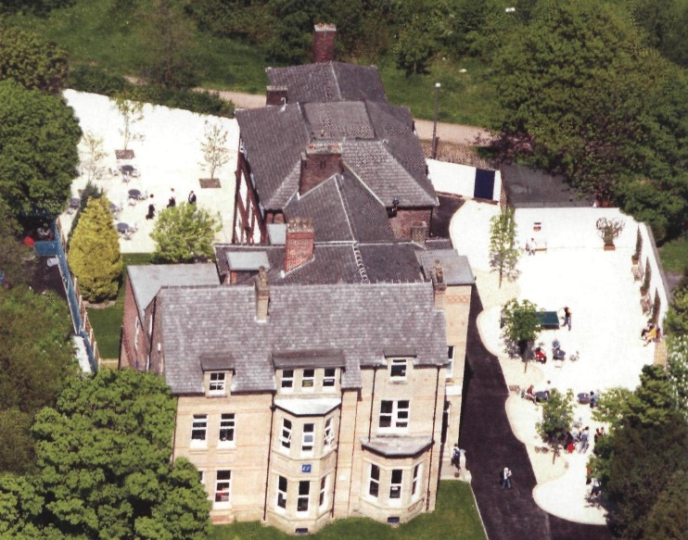
Most big towns in Britain have both a university and a college of higher education. Universities offer three- and four-year degree courses; colleges of higher education offer both two-year HND (Higher National Diploma) courses, as well as degree courses.
A degree is the qualification you get from university when you pass your final exams. You are then awarded a BA (Bachelor of Arts), BSc (Bachelor of Science) or BEd (Bachelor of Education).
Undergraduates, students who are studying for their first degrees, go to large formal lectures, but most of the work takes place in tutorials: lessons in groups of ten or more when the students discuss their work with the lecturer.
When you complete your first degree, you are a graduate. Some students then go on (continue) to do a second course or degree, called a postgraduate course or degree. These students are then postgraduates and they often get: an MA (Master of Arts), e.g. a Masters in English, an MSc (Master of Science), e.g. a Masters in biology or a PhD (Doctor of Philosophy) (minimum three years), e.g. a PhD in computer science.
The head of a department at a university is usually called a professor. An ordinary teacher or lecturer is not a professor.

2.11 Find the following words and expressions in the text and give their Russian equivalents.
College of higher education, offer a course, offer a degree course, pass final exams, be awarded a degree, undergraduate, complete the first degree, tutorial, lecturer, professor, do a second course, postgraduate.

2.12 Answer the following questions.
1. In your opinion, what is the title of the text? 2. What courses do English universities offer? 3. What is a degree? 4. What is a tutorial? 5. What degrees are British students awarded? 6. How is the head of department called?

2.13 Make a short summary of the text. Use the following phrases:
The title of the text is …
The text deals with … (speaks about…, presents…, shows…, is devoted to …, gives some information on …, discusses).
According to the text …
I think …
In my opinion…

Grammar
6.31 Complete the text with the verbs.

be
get up
start
not eat
not finish
have
go
love
eat
live
not like
visit
study
finish
stay
work
fly
want

1. Philippa Robbins ____ a scientist. 2. She ____ in a flat in Oxford, and she ____biology at the university. 3. Every day she ____ at 6.30 and ____ three cups of coffee. 4. She ____ anything for breakfast. 5. She ____work in her laboratory at 7.00, and she ____ until lunchtime. 6. Then she ______ for a short walk in the park. 7. She usually ____ work at 6.00, but sometimes she ____ until 10.00. 8. In the evening she often ____ in a restaurant, because she ____ cooking. 9. Every winter she and her husband ____ to America, where they ____ an American laboratory. 10. They ____ in a friend’s house for two weeks. 11. They never ____ to go back to Oxford, because they _____ hot weather!

6.32 Look at the list Write about computers. What can they do? What can’t they do?

1. count
2. translate
3. speak English
4. play chess
5. do crosswords
6. hear

7. see
8. check spellings
9. make music
10.have conversations
11.write books
12.think

6.33 Complete the questions with can and a suitable verb. Then match each question with an answer.
ride use cook speak drive play (x 2)

a_____ you _____ the piano?
b_____you ____any foreign languages?
c_____ you _____the guitar?
d_____ you _____ a motorbike?
e_____you _____ Chinese food?
f_____ you _____a word processor?
g_____you _____ a car ?
1. Yes, I can. French and Spanish.
2. No, I can't, but I can type.
3. No, I can't. I like cars.
4. Yes, I can. I have a Fiat Punto.
5. No, I can't, but I can play the piano.
6. Yes, I can. I like playing Mozart.
7. No, I can't, but I love eating it.

6.34 Complete the sentences with some or any.
1. I don't have ______ money in my pocket, but I have ______ money in the bank.
2. Are there _____ letters for me this morning?
3. I want ______ books from the library.
4. You have _____ lovely pictures in your house.
5. Are you Canadian? I have _____ good friends in Canada.
6. Do you have ______brothers or sisters?
7. There aren’t ______shops on our campus, just a cafe.
8. Is there _____ pen on the table?
9. _____ people like flying, but other people don't.
10. Would you like to listen to ______ music? I have a new CD.

6.35 Complete the questions with How much ... ? or How many ... ?, then answer them.
1. ______ homework do you get?
2. ______ English books do you have?
3. ______does a cup of coffee cost?
4. ______languages do you speak?
5. ______people are there in your class?
6. ______weeks' holiday do you have in summer?
7. ______coffee do you drink a day?

