https://disrm1.zabgu.ru/b/fe9-tcc-cm4

Ребята, это ссылка на подключение к он-лайн занятию.

2.10 Read the text and find information about:
а. British colleges and universities
b. graduate and post-graduate degrees
c. forms of instruction
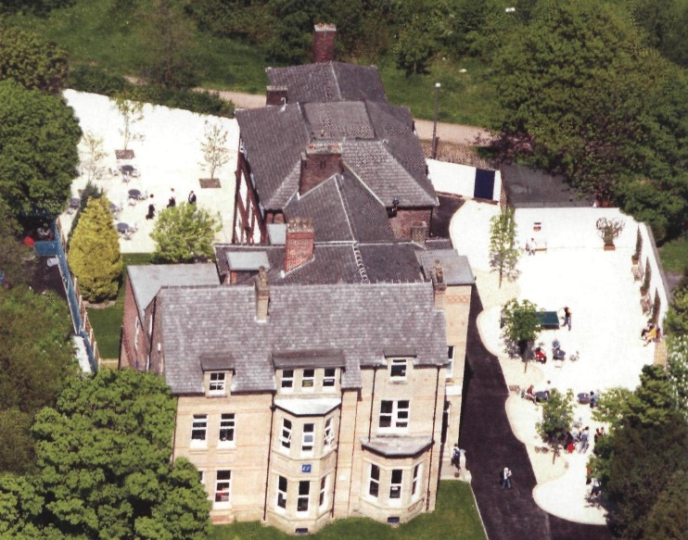
Most big towns in Britain have both a university and a college of higher education. Universities offer three- and four-year degree courses; colleges of higher education offer both two-year HND (Higher National Diploma) courses, as well as degree courses.
A degree is the qualification you get from university when you pass your final exams. You are then awarded a BA (Bachelor of Arts), BSc (Bachelor of Science) or BEd (Bachelor of Education).
Undergraduates, students who are studying for their first degrees, go to large formal lectures, but most of the work takes place in tutorials: lessons in groups of ten or more when the students discuss their work with the lecturer.
When you complete your first degree, you are a graduate. Some students then go on (continue) to do a second course or degree, called a postgraduate course or degree. These students are then postgraduates and they often get: an MA (Master of Arts), e.g. a Masters in English, an MSc (Master of Science), e.g. a Masters in biology or a PhD (Doctor of Philosophy) (minimum three years), e.g. a PhD in computer science.
The head of a department at a university is usually called a professor. An ordinary teacher or lecturer is not a professor.

2.11 Find the following words and expressions in the text and give their Russian equivalents.
College of higher education, offer a course, offer a degree course, pass final exams, be awarded a degree, undergraduate, complete the first degree, tutorial, lecturer, professor, do a second course, postgraduate.

2.12 Answer the following questions.
1. In your opinion, what is the title of the text? 2. What courses do English universities offer? 3. What is a degree? 4. What is a tutorial? 5. What degrees are British students awarded? 6. How is the head of department called?

2.13 Make a short summary of the text. Use the following phrases:
The title of the text is …
The text deals with … (speaks about…, presents…, shows…, is devoted to …, gives some information on …, discusses).
According to the text …
I think …
In my opinion…

GRAMMAR

6.7 Write questions for these answers.
1) What_________? - Paul Dalen’s a maths student.
2) How_________? - He’s twenty three.
3) What_________? - His address is 41 King Street, London.
4) What _________? - His friends are students too.
5) What_________? - Their names are Mark and Jane.
6) How _________? - Mark’s twenty two. Jane’s twenty four.

6.8 Read the text. Correct the sentences below making them negative.
Hi, I am Alex.
I am British. I am from London. It is a big city.
I am a physicist. I am interested in physics but I am not interested in politics. I am good at sports.
I am fond of Susan. She is nice and kind. Susan is a student. She is fond of art and music. She is clever.

1. He is Allen.
2. He is Canadian.
3. He is a student.
4. He is interested in politics.
5. Susan is a secretary.
6. She is fond of sports.

6.9 Make the questions to these answers.

1. She’s French.
2. They are at college.
3. I’m tired.
4. I’m right.
5. He was born in 1988.
6. We are fond of sports.
7. He’s interested in politics.
8. They are first year students.

6.10 Answer the questions.
1. What day is it today?
2. What day will it be tomorrow?
3. What day was it yesterday?
4. What days are “the weekend”?
5. What century is it now?
6. What month is it now?
7. What day will it be the day after tomorrow?
8. What day was it the day before yesterday?
9. On what days are your English classes?
10. When is Christmas Day?
11. When is Valentine’s Day?
12. What are the dates of public holidays in your country?

6.11 Put was / were / wasn’t into the gaps.
Sue _________ you at Eve's party last Saturday?
Bill Yes, I_________.
Sue_________ it good?
Bill Well, it_________ OK.
Sue_________ there many people?
Bill Yes, there_________.
Sue _________ Tom there?
Bill No, he_________. And where_________ you?
Sue Oh... I_________ at Adam's party! It_________ brilliant!

6.12 Possessive 's or is? Write P if’s = Possession. Write is if 's = is.

1. John's car is new.
2. It's a Mercedes.
3. Jane's a manager.
4. Jane's husband is thirty-five.
5. Tom's in Canada at the moment.
6. Tom's office is in Bristol.
7. My friend's English is very good.
8. Peter's a teacher.
9. Peter's school is in the town centre.
10. It's cold today.

6.13 Translate into English.
1. Меня зовут Андрей. Я студент. Я интересуюсь политикой и увлекаюсь спортом. Мне очень нравится Лена. Она милая и добрая.
2. Ира из Москвы. Она – журналист. Она увлекается искусством.
3. Мой брат – студент. Я не уверен, что он хороший студент. Он часто отсутствует на занятиях. Вчера он опоздал на лекции. Будет ли он хорошим специалистом?

6.14 Look at the picture of Suzie's bedroom. Are the sentences true or false ?

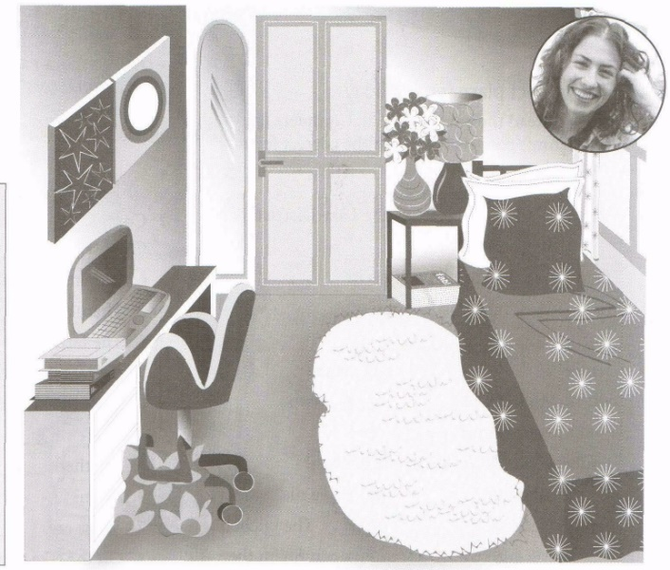
1. There's a chair in front of the desk.
2. There are some flowers in the bedroom.
3. There's a mirror on the wall next to the window.
4. There aren't any plants.
5. There are some magazines under the table.
6. There’s a lamp next to the bed.
7. There's a plant next to the door.
8. There's a photo on the table, in front of the flowers.
9. There's a bag on the chair.
10. There are some pictures on the wall.

6.15 Look at the picture of Susie’s bedroom. Complete the questions and answers.
1. A. Is there a computer?
B. Yes, ___________. It’s __ the desk.
2. A. ___________ there any photos?
B. No, ___________.
3. A. Is ___________ a bag?
B. Yes, ___________. It’s __ the chair.
4. A. ___________a plant?
B. No, ___________.
5. A. ___________ flowers?
B. Yes, ___________. They’re __ the table.
6. A. ___________ magazines?
B. Yes, ___________. They’re __ the table

