Science and technology

  - You are probably familiar with the traditional branches of science, e.g. chemistry, physics, botany and zoology. But what about these newer fields? Read and translate information about the new branches of science.
genetic engineering: the manipulation of genetic material (DNA) of living things to alter hereditary traits
ergonomics: the study of the design of physical working spaces and how people interact with them
molecular biology: the study of the structure and function of the organic molecules associated with living organisms
cybernetics: the study of the way information is moved and controlled by the brain or by machinery
information technology: the study of technology related to the transfer of information (computers, digital electronics, telecommunications)
bioclimatology: the study of how climate affects living things
geopolitics: the study of the way geographical factors help to explain the basis of the power of nation states
nuclear engineering: the study of the way nuclear power can be made useful
cryogenics: the study of physical systems at temperatures less than 183°C
astrophysics: the application of physical laws and theories to stars and galaxies
voice technology: technology which enables machines to interpret speech

1.2 Complete the following list with the name of the specialists in the particular fields.
Example: science………………scientist
chemistry ……..
physics ……..
zoology ………
genetics ……….
information technology ……..
cybernetics ……….
civil engineering ……..
astrophysics ……

1.3 Give each of the sciences from exercise 1.1 a number from 0 to 5 depending on whether it doesn’t interest you at all (0) or interests you enormously.

1.4 Below you have some of the amazing achievements of modern technology. Match the names on the left with the definitions on the right.
1. video recorder | a. a kind of sophisticated typewriter using a computer
2. photocopier | b. a machine which records and plays back sound
3. fax machine | c. a machine which records and plays back sound and pictures
4. tape recorder | d. a camera which records moving pictures and sound
5. modem | e. a machine for chopping up, slicing, mashing, blending, etc.
6. camcorder | f. a machine which makes copies of documents
7. word processor | g. a machine which makes copies of documents and sends them down telephone lines to another place
8. food processor | h. a piece of equipment allowing you to send information from one computer down telephone lines to another computer
1.5 Write descriptions like those in exercise 1.4, for the following objects.
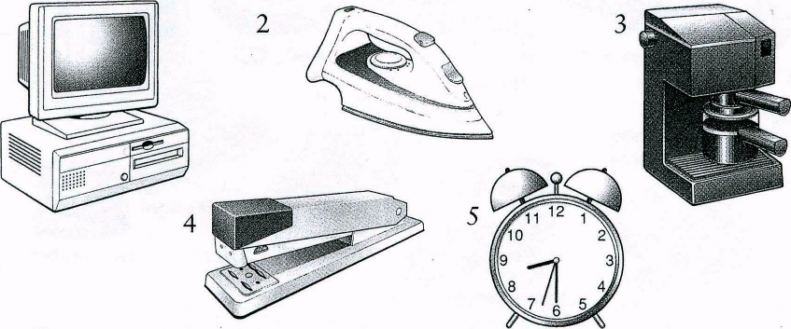
1

Grammar

5.1 Look at the picture. Say what children are doing at the math class.

The director is looking into the classroom. A young teacher is speaking. But the children are not interested in math. They are doing something else. Tom______ (not/write) in his notebook, he______ (read) a history book. Sally______ (not/listen) to the teacher, she______ (talk) with her friend. Sandy______ (not/look) at the blackboard, she______ (talk) on the mobile phone.

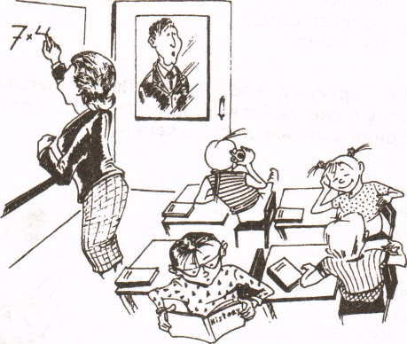
5.2 Put in am/is/are/do/don't/does/doesn't.
1. Excuse me, ______ you speak English?
2. Where ______ you come from? I ______from Canada.
3. A: Where’s George?
B: He ______ having lunch in the café.
4. What ______ she do? She's a programmer.
5. I ______want to go out. It ______ raining.
6. I can't talk to you at the moment. I ______ working.
7. George is good at tennis, but he ______ play very often.
8. ______ you enjoy your English course?

5.3 Put the verb in the Present Progressive (I am doing) or Present Simple (I do).
1. ______ (you/study) full-time at university?
2. Tom______ (have) a lecture at the moment.
3. They______ (not/skip) lectures.
4. Listen! Somebody______ (speak).
5. How often______ (you/have) seminars?
6. A: Excuse me, but you______ (sit) in my place.
B: Oh, I'm sorry.
7. I'm sorry, I______ (not/understand). Please, speak more slowly.
8. A: Where are you, Roy?
B: I’m in the sitting-room. I______ (read).
9. What time______ (she/finish) work every day?
10. He_____ (not/usually/drive) to the university. He usually_____ (walk).

5.4 Are the sentences correct or incorrect? Correct the mistakes.
1. I usually working from 7.30-13.30.
2. Does he has his own car?
3. I often having dinner with them.
4. He never skip classes.
5. She does not reads a lot.
6. Where are you work now?
7. She usually do her homework in the library.
8. We don't live on campus now.
9. She doesn't works in London.
I0. Is he study hard?

5.5 Choose the correct form of the verb.
1. I am thinking / think it's not easy to learn English.
2. She is having/has a shower. Can you call later?
3. She isn't having/doesn't have a new car.
4. He is having/has a lecture at the moment.
5. They are wanting/want to go to the library.
6. I don't think she is understanding/understands.
7. I am liking/like programming.
8. He is knowing/knows a lot about computers.

