Reading and discussion

2.1. Before reading the text below, ask the students of your group their opinions on some aspects of the problem of technological progress.
Public Opinion Poll
1. What do you think of science? Do science and technology do
- more good than harm
- more harm than good
- about equal ?

2. Do you think that scientific discoveries can have very dangerous effects?
- Yes
- No

Discuss the results of the public opinion poll with your partner. Express your own opinion. Use the following phrases:
I think … I guess … My point is that … In my opinion … To my mind …As far as I know …

2.2 Read the international words and guess their meaning.
Natural, characteristic, civilization, dominant, role, telephone, television, automobile, intellectual, result, activity, technical, innovation, information, technology, telecommunication, transistor, heterostructure, medical, instruments, optical, diode, mobile, satellite, telephony, computer, microprocessor, fundamental, industrial, revolution, position, effect.

2.3 Practise in reading and give Russian equivalents of the following words and word combinations.
Natural science, characteristic feature, present civilization, influence, course, materially, intellectually, distinguish, mention, automobile, mind, device, impact, intellectual enterprise, outcome, range, human knowledge, double, previously, technology, semiconductor, ultra-rapid, decisive, fibre, storage, light-emitting diode, satellite, integrated circuit, microprocessor, occupy, existence, research, decrease.
2.4 What parts of speech are the following words? Put them into the correct column. Translate the words.
Natural, civilization, development, western, dominant, materially, countless, application, intellectual, invention, activity, intellectually, knowledge, previously, technical, innovation, radically, electronic, computer, technology, transistor, telephony, semiconductor, optical, communication, medical, storage, player, reader, microprocessor, discovery, fundamental, industrial, revolution, central, technological, existence
Noun | Adjective | Adverb
…….. | …… | …………

  - Practise saying these dates.
Example: 3 April 1999 – The third of April, nineteen ninety-nine or April the third, nineteen ninety-nine.
4/5/1930, 23 June 1900, 29/2/2000, 2 March 1947, 17 September 1960, in the 1970s, by 2000

2.6 Read and translate the text.

Science and technological progress in modern society
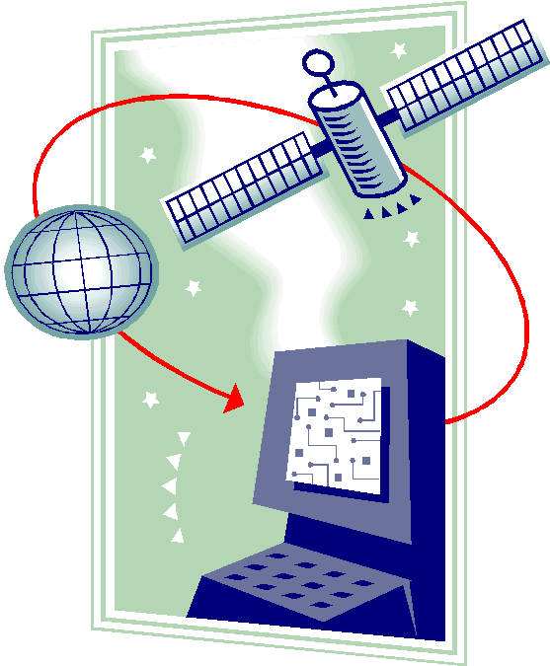
Natural science is the main characteristic feature distinguishing the present civilization from the civilizations in the past. From the early beginning in the sixteenth century, the development of science has influenced the course of western civilization. Today science plays the most dominant role. We live in a world that, materially and intellectually, has been created by science.
On a material level one can mention the telephone, the television, the automobile, or any of the countless devices invented by the application of science. On the other hand, the impact of science on the mind of a man is far more important. Science is an intellectual enterprise, an attempt to understand the world in a particular way. All the inventions mentioned above are the results and outcomes of this intellectual activity.
Over the past 150 years the range of human knowledge has been doubled every twelve to fifteen years. In 1930 man knew four times as much as he did in 1900. By the year 2000 it was a hundred times what it had been a century previously.
The second part of the twentieth century brought a number of technical innovations. Information technology (IT) has changed our society radically. It comprises electronic computer technology and telecommunications technology.
The invention of the transistor in 1947 marked the start of the development of modern semiconductor technology. Ultra-rapid transistors and semiconductor lasers based on heterostructures are playing a decisive part in modern telecommunications. They are used in space technology, computers, fibre-optical communication, medical instruments, and in optical data storage as in CD players, bar-code readers and light-emitting diodes. Heterotransistors are very important in satellite communication and mobile telephony.
The rapid development of electronic computer technology really started with the invention of the integrated circuit (IC) around 1960 and the microprocessor in the 1970s. The integrated circuit is both a technical invention and a discovery in physics. Invention of the IC is so fundamental that it already has the characteristic of a second industrial revolution.
The point that science occupies a central position in modern technological innovations and modern society is clear. It dominates man’s whole existence. Research and innovations in technology should improve society’s living and working conditions. They can also help to decrease the negative effects of technical and social changes.

  - Look through the text and find English equivalents for the following Russian words and phrases.
Естествознание, характерная особенность, современная цивилизация, развитие науки, на материальном уровне, многочисленные устройства, применение науки, влияние науки, интеллект человека, особым образом, с другой стороны, интеллектуальная деятельность, итог, изобретение, в четыре раза больше, технические нововведения, информационная технология, полупроводниковая технология, гетероструктура, играть решающую роль, современные телекоммуникации, волоконно-оптическая связь, хранение информации, считыватель штрихкода, светодиод, интегральная микросхема, микропроцессор, улучшать условия жизни и работы общества, уменьшать отрицательное влияние.

Grammar

5.6 Complete the sentences with the correct form of be.
Alex is speaking to his friend Robert.
Alex: What ______ you so happy about?
Robert: Sandy and I ______ going to have a date at the weekend.
Alex: Are you? That's fast work. That's great! Which night ______you going to see her? Friday or Saturday?
Robert: I ______ going to see her on Sunday. She ______ not going to be in town on Friday or Saturday.
Alex: Where ______she going to be?
Robert: She ______going to be with her friends in Liverpool.
Alex: What ______ you going to do on Sunday?
Robert: I ______ going to take her out to dinner.
Alex: Where ______you going to take her?
Robert: I ______going to take her to an Italian restaurant. This girl ______terrific!

5.7 Fiona is phoning Susan. She would like to meet with her. But Susan is very busy this week. Look at the notes in Susan’s diary and complete the conversation.

Monday
18.00 Meet Alex
Tuesday
17.00 — 20.00 Get ready for the test in algebra
21.00 Go to the cinema with Edna
Wednesday
17.00 — 20.00 Get ready for the test in algebra
Thursday
18.00 Write the test in algebra
Friday
20.00 Visit parents
Saturday
21.30 Go to the pub with Alex
Sunday
Relax

Fiona: Hi, Susan. How are you?
Susan: Fine, thanks. And you?
Fiona: Not bad. Let's go to the bar on Monday.
Susan: I'm sorry. But I'm going to meet Alex on Monday.
Fiona: What about Tuesday?
Susan: _________________
Fiona: Let's meet on Wednesday.
Susan: _________________
Fiona: May be Thursday then?
Susan: _________________
Fiona: What about Friday?
Susan: _________________
Fiona: You are really busy this week!
Susan: That’s true. But I am going to be free on Saturday after 2 o’clock. Let’s go to the club on Saturday night.
Fiona: OK. See you on Saturday.
Susan: See you.

5.8 Complete the sentences using the verbs in the box.
am living like play comes am going to look is studying
- Carol ______from Hong Kong. She ______ mathematics at the University of Newcastle, in the North of England. “I ______the people very much. They are warm and friendly. I ______ on a campus. It takes me five minutes to walk to the city centre, where I can shop, or go to cafes and clubs. I often ______ table tennis. I______ for a job in a bank when I finish. Maybe here in Newcastle. Who knows?”
speaks study am doing am going
2. Steven ______three languages – German, English, and Russian. “I ______ law at Harvard. But now I ______ a course in international studies in Paris. After the course, I ______ on holiday to Russia. I can’t wait to see the Hermitage Museum in St. Petersburg.”
come teaches helps are going to train are staying are doing love
3. Nick and Holly ______ voluntary work in Kenya for a year. They ______at Camp Kenya with fifty other volunteers, who ______ from all over the world. Holly ______ English, and Nick ______ local people to build schools and playgrounds. “The kids ______ football”, says Nick. When Nick and Holly go back to England, they ______ to be teachers.

5.9 Put these sentences into the negative form and make the question.
1. Henry can drive.
2. He can do what he likes.
3. We have to wear uniform.
4. We have to work hard.
5. You should phone us if you’re in trouble.
6. He should say yes.
7. You must help you parents!
8. I must visit Peter. He’s in hospital.
9. I may get home at midnight.

5.10 Answer the questions about you.
1. Can you always do what you want?
2. May you bring a mobile phone to class?
3. What time do you have to get back home?
4. Must you do your homework every day?
5. Must you arrive for lesson on time?
6. May you wear jeans at university?
7. May you smoke?
8. Should you smoke?
9. Should you go out when it’s dark?
10. Should you drink alcohol?
11. Do you have to go to work?
12. Do you have to go shopping?
13. Do you have to do the cooking?
14. Do you have to do military service?

