Соловьева Ирина Николаевна
24.11.2020
Группа УП-19
Иностранный язык в профессиональной деятельности
Практическое занятие
Устная тема: HOW TO SELECT THE BEST CANDIDATES
Грамматическая Тема: THE PASSIVE VOICE
Задания должны быть выполнены и представлены в личном кабинете студента до 30 ноября 2020 г.
Рекомендуемая литература:
Агабекян И.П. Английский язык для менеджеров. : учеб. пособие. – М.: ТК Велби, Изд-во Проспект, 2007. - 352 с.
Рекомендуемые ресурсы:
http://www.correctenglish.ru/theory/grammar/voice/
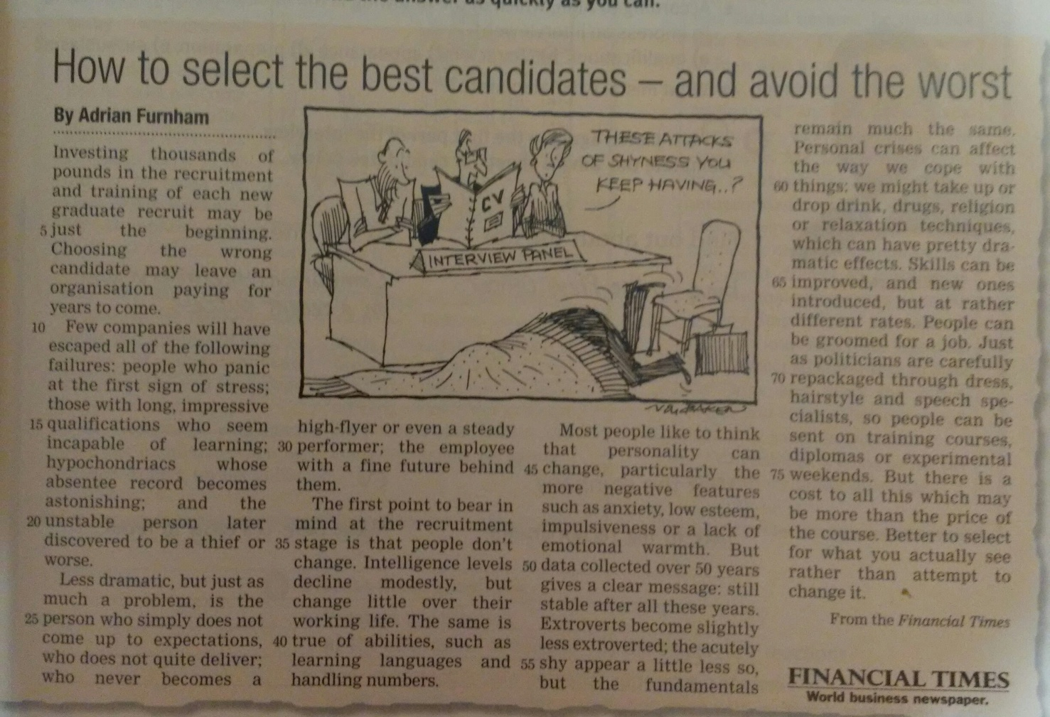
Задание 1. Make up the summary of the article. Write 6-8 sentences.
Задание 2. Learn the vocabulary to the article Now to Select the Best Candidates – and Avoid the Worst

Задание 3. Copy the sentences and indicate the tense* of the passive predicate. Make the sentences Active then translate into Russian.

*tense - время

1. The dishes were being washed by my mother when I came home last night.
2. Nice clothes are produced in Turkey by some factories.
3. The suspects have been seen by a group of boys near the bus.
4. The house is being cleaned by the maid at the moment.
5. The house was demolished by the hurricane last night.
6. History books are read by the students in this class.
7. I hope a nice dinner will be prepared by the cook for tomorrow’s party.

