Соловьева Ирина Николаевна
15.12.2020
Группа УП-19
Иностранный язык в профессиональной деятельности
Практическое занятие
Устная тема: JOB INTERVIEWING
Грамматическая Тема: THE PASSIVE VOICE
Задания должны быть выполнены и представлены в личном кабинете студента до 21 декабря 2020 г.
Рекомендуемая литература:
Агабекян И.П. Английский язык для менеджеров. : учеб. пособие. – М.: ТК Велби, Изд-во Проспект, 2007. - 352 с.
Рекомендуемые ресурсы:
http://www.correctenglish.ru/theory/grammar/voice/
Задание 1. Alan Lawson, National Sales Manager with a Japanese electronics company, is talking about interviewing. Read a part of his interview. Translate into Russian.
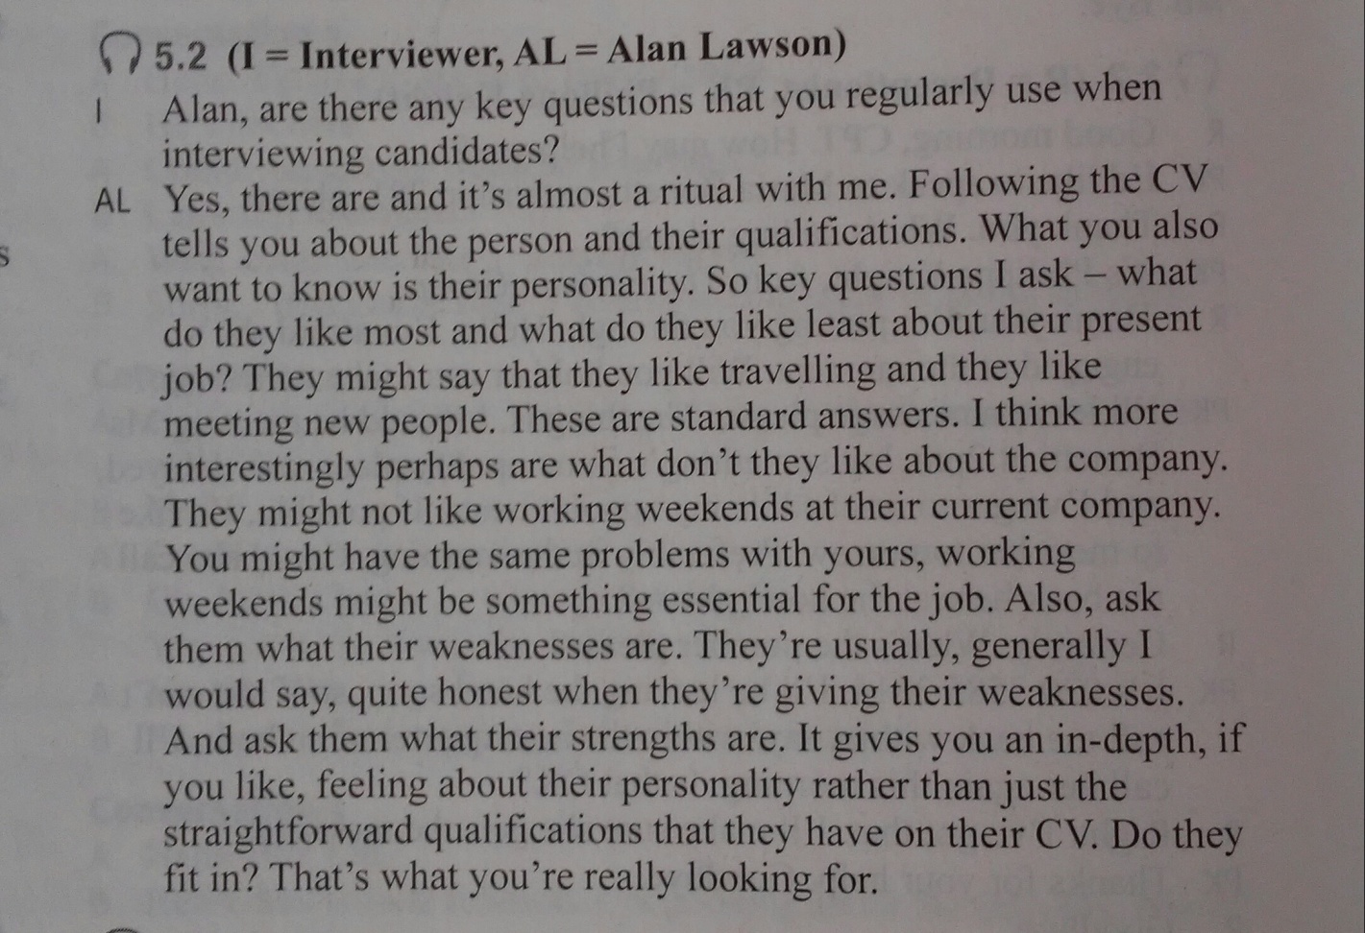

Задание 2. Answer the questions
1. What four questions does Alan usually ask candidates?
2. What examples does he give of candidates’ likes and dislikes?
3. Why is the question about the person’s weaknesses important to Alan?
Задание 3. Give Russian equivalents for
- essential
- weakness
- strength
- honest
- personality
Write the transcription of the words and practice their pronunciation.
Задание 4. Put the verb into the correct form, present simple or past simple, active or passive. Indicate the tense* and the voice**.
*tense – время
**voice - залог
- While I was on holiday, my camera (to steal) from my hotel room.
- While I was on holiday, my camera (to disappear) from my hotel room.
- Why (Sue / to resign) from her job? Didn't she enjoy it?
- Why (Ben / to fire) from his job? Did he do something wrong?
- The company is not independent. lt (to own) by a much larger company.
- I saw an accident last night. Somebody (to call) an ambulance but nobody (to injure), so the ambulance (not to need).
- Where (these pictures / to take)? In London? (you / to take) them, or somebody else?
- Sometimes it's quite noisy living here, but it's not a problem for me - I (not to bother) by it.

