Соловьева Ирина Николаевна
22.12.2020
Группа УП-19
Иностранный язык в профессиональной деятельности
Практическое занятие
Устная тема: JOB INTERVIEWING
Грамматическая Тема: THE PASSIVE VOICE
Задания должны быть выполнены и представлены в личном кабинете студента до 28 декабря 2020 г.
Рекомендуемая литература:
Агабекян И.П. Английский язык для менеджеров. : учеб. пособие. – М.: ТК Велби, Изд-во Проспект, 2007. - 352 с.
Рекомендуемые ресурсы:
http://www.correctenglish.ru/theory/grammar/voice/
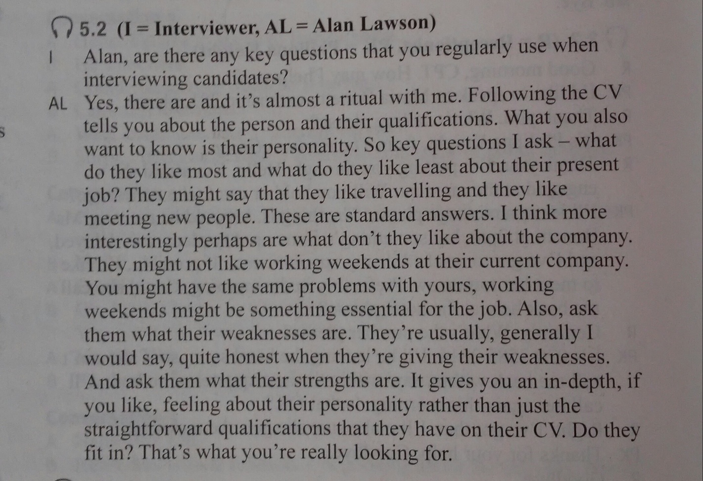

Задание 1. Retell the text using the following questions as guidelines.
1. What four questions does Alan usually ask candidates?
2. What examples does he give of candidates’ likes and dislikes?
3. Why is the question about the person’s weaknesses important to Alan?
Задание 2. Choose the correct word or phrase. Write the sentences in full! Underline the predicate and *identify its tense and voice (*определите его время и залог).

1. The prime minister has / has been criticized for his recent actions. 2. When I walked past the Brown`s house, their new sofa was being/has been delivered. 3. Our teacher was / has told us to take our favorite book to school tomorrow. 4. I think my mobile was / has been stolen! 5. Ann was/has chosen to play the lead role in the play. 6. I`m sleeping downstairs because my bedroom is being /has been painted. 7. This picture was/has probably taken during winter. 8. Your essays must be/have handed in on Friday. 9. Someone was/has left their wallet on the floor. 10. Do you know that the bank down the street is/has been robbed? 11. Treasure Island was/has been written by R.L. Stevenson. 12. It was a real shock when my dad was/has fired from his job. 13. The Vikings had/had been visited America before it was/has discovered by Columbus. 14. When we got to the airport, we learned that our flight was/had been delayed. 15. Will your ticket for the concert pay/be paid for by you or your parents?

