Соловьева Ирина Николаевна
16.02.2022
Группа РЕГ-19
Устная практика (второй иностранный язык)
Практическое занятие
Устная тема: AMERICAN SYSTEM OF EDUCATION
Грамматическая Тема: THE MODAL VERBS
Задания должны быть выполнены и представлены в личном кабинете студента до 15 февраля 2022 г.
Рекомендуемая литература:
American English for Everyday and Academic Use. Американский вариант английского языка: учеб. пособие для взрослых. Продвинутый курс / отв. ред. Ю.П. Третьяков. С-Пб: Наука, 2005.
Рекомендуемые ресурсы:
https://englex.ru/modal-verbs-in-english/
Ссылка на онлайн занятие:
﻿Подключиться к конференции Zoom
https://us04web.zoom.us/j/6139335550?pwd=T3pSOXFWcjFIcCtkS1V4Yk95aFV2Zz09

Идентификатор конференции: 613 933 5550
Код доступа: 123456
Задание 1. Read and translate the text “The Main Concept of American Education”
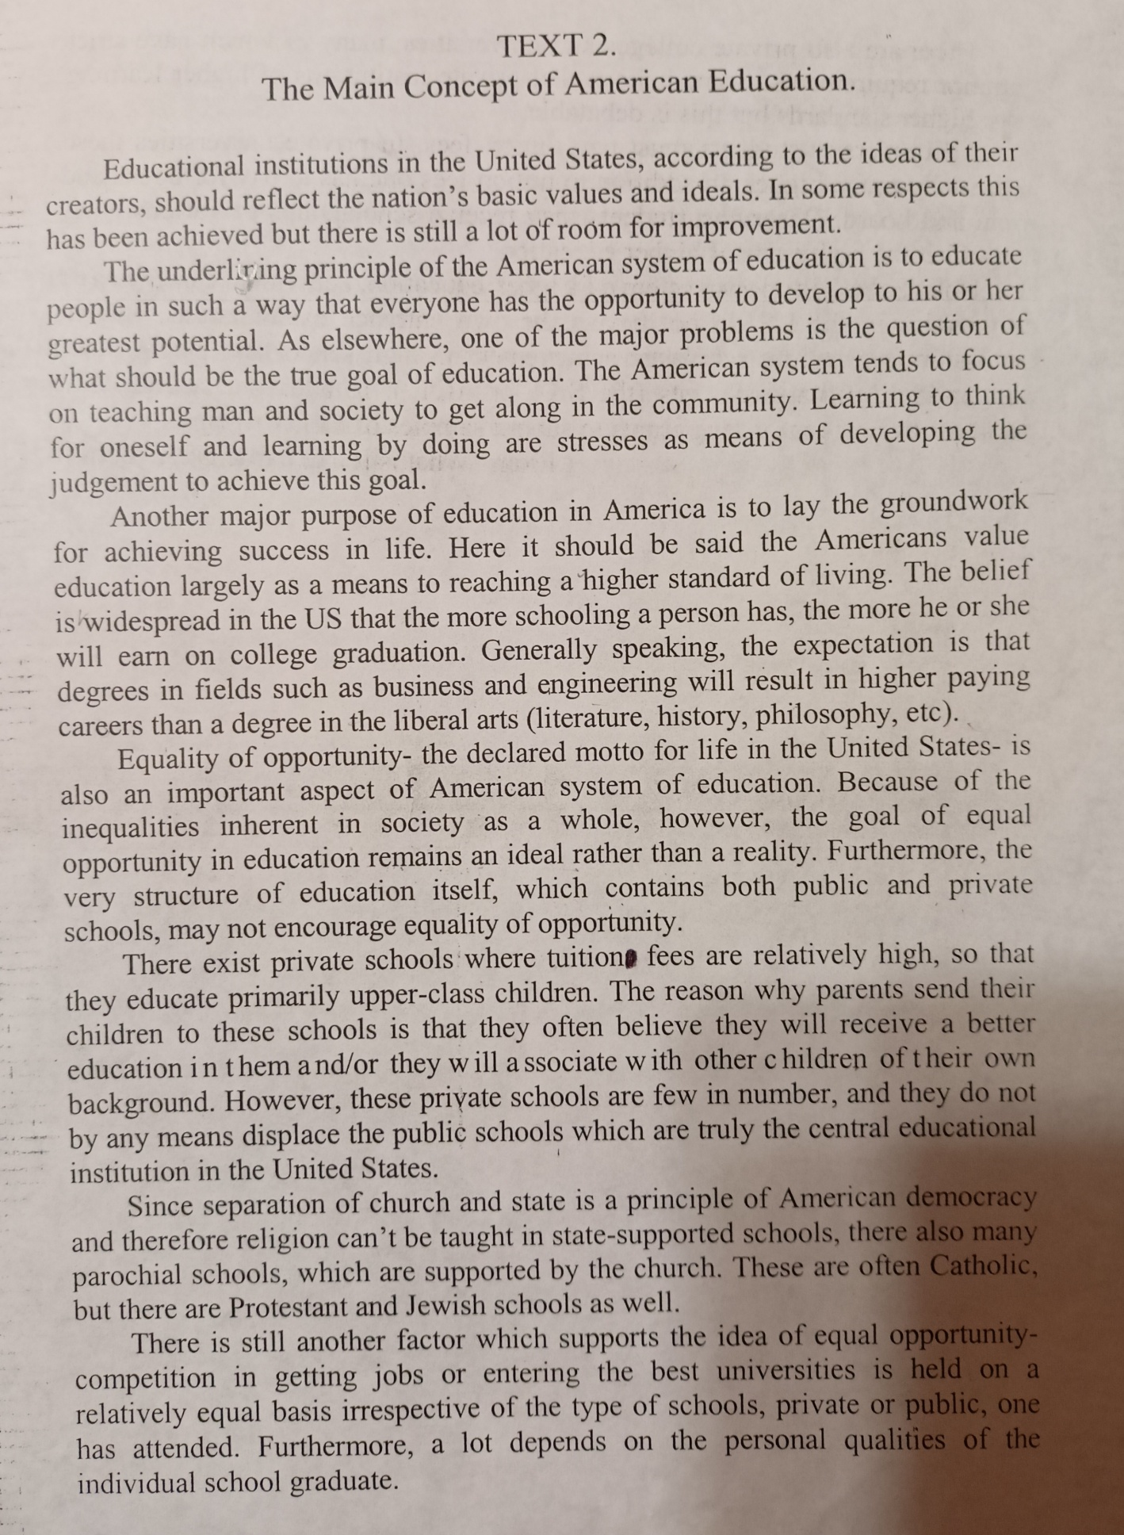
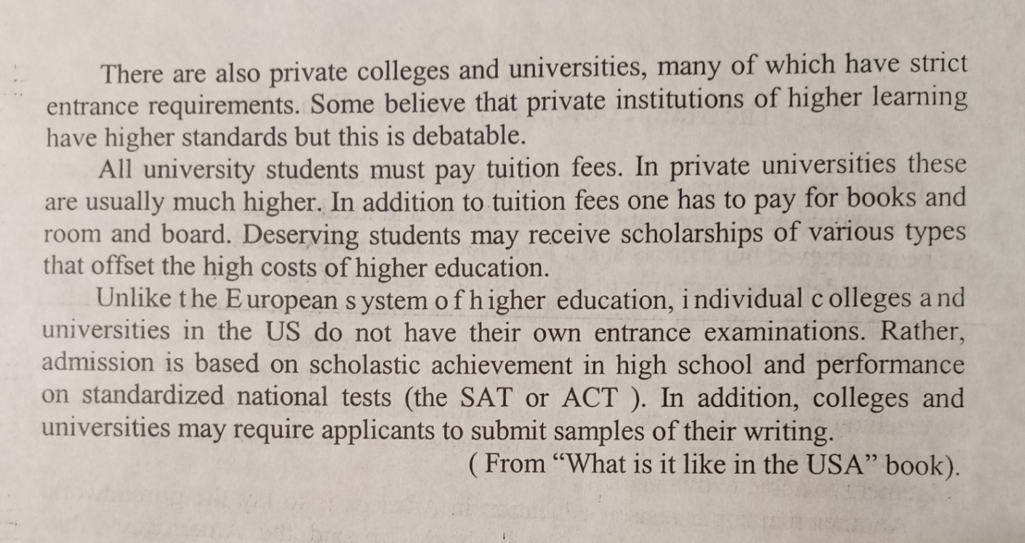
Задание 2. Answer the questions on the text “The Main Concept of American Education”
1. What is the core principle of American system of education?
2. What are the main purposes of education in the USA?
3. Do Americans value education? Why?
4. Has equality of opportunity been achieved in the area of education?
5. What types of schools are there in the USA?
6. Can a high-school leaver get a higher education free of charge?
7. Do American college and university applicants have to take entrance examinations?
Задание 3. Complete the sentences with can/could in the positive or negative form.
1. Penguins swim very well. 2. I run very fast when I was younger. 3. It’s snowing hard so we go out now. 4. You play the piano when you were seven? 5. You have a nice bicycle. You ride it? 6. He has a broken leg so he walk for a few days. 7. I sleep last night. 8. We came as fast as we. 9. You park your car here. It’s forbidden. 10. Sam go to the party because he was too busy. 11. I looked everywhere but I find my keys. 12. Dinosaurs fly? 13. If you are hungry, you eat a banana. 14. Her grandmother was bilingual: she speak both English and Spanish. 15. You play the piano? – No, I. I have never studied it.

